FOR IMMEDIATE RELEASE
Contact:
Phone:

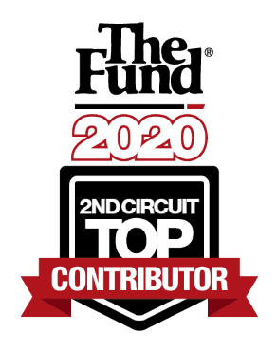

NABORS, GIBLIN & NICKERSON, P.A. NAMED A 2020 TOP CONTRIBUTOR

IN SECOND CIRCUIT

(Orlando, Fla.) – MARCH 11, 2021 – Attorneys' Title Fund Services, LLC (The Fund), today announces Nabors, Giblin & Nickerson, P.A. named a Top Contributor of the Second Circuit in the state of Florida for 2020. The Fund’s Circuit Top Contributor award recognizes the top three Fund Member firms in each of Florida’s 20 judicial circuits for total policy remittance.

“We are proud to recognize Nabors, Giblin & Nickerson’s achievement and thank them for their loyalty to The Fund and dedication to their clients,” said Jimmy R. Jones, The Fund’s CEO.

Each year, The Fund recognizes the top performing Member firms in Florida. The support and loyalty of top performing Members allows The Fund to continue to serve 2,500 Member firms throughout Florida.

About The Fund:

Backed by the strength of Old Republic Title, Attorneys' Title Fund Services, LLC (The Fund) promotes and facilitates the real estate practices of our Members in their protection of the public. More than 4,000 Members throughout Florida rely on us for next-level residential and commercial title services, best-in-class legal education, and practice-enhancing resources.
For more information, visit http://www.thefund.com.

About Nabors, Giblin & Nickerson:
Nabors, Giblin & Nickerson, P.A. was established in 1984 so that its principals could concentrate their practice upon the representation of local government on a statewide basis. Consistent with this concept the firm has developed into a full-service law firm for local governments, which includes a real estate practice. NG&N has blended a specialized Wall Street public finance practice with hands-on local government experience to create a law firm with a unique focus.
###

